SI608 Fall 2024 – Lab 1

Today I just want you to start playing with python and NetworkX. It’ll be a pretty light weight lab. You can find the manual to networkx here: https://networkx.github.io/documentation/stable/reference/index.html if you get stuck
Step 0) Install NetworkX:
If you do not have python installed, refer to: https://www.python.org
If you do not have python installed but networkx not installed, refer to: https://networkx.github.io/documentation/stable/install.html

Step 1) Run python
Step 2) Make your first graph
Import networkx using the command:
import networkx as nx
You will now have the networkx library “bound” to the nx variable. Let’s make a new graph:
g = nx.Graph()
g.add_edge(‘a’,’b’) # this will create two nodes AND an edge
g.add_edge(‘b’,’c’)
g.edd_edge(‘a’,’c’)
g.add_edge(‘c’,’d’)
If you have your environment set up to plot, you can see what you did by typing:
import matplotlib.pyplot as plt # you only need to do this once
nx.draw_networkx(g) # to draw the graph
plt.show() # to force it to draw to the screen
You’ll get something that looks like the following:
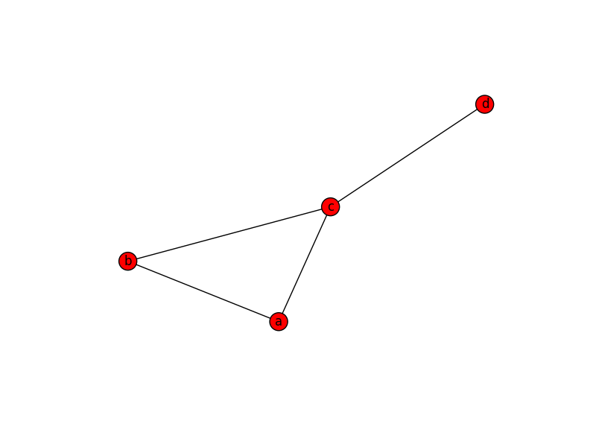

What if you did not want to see node labels? You can use:
nx.draw_networkx(g, with_labels=False) # draw graph with node labels
You will see something that looks like the following:
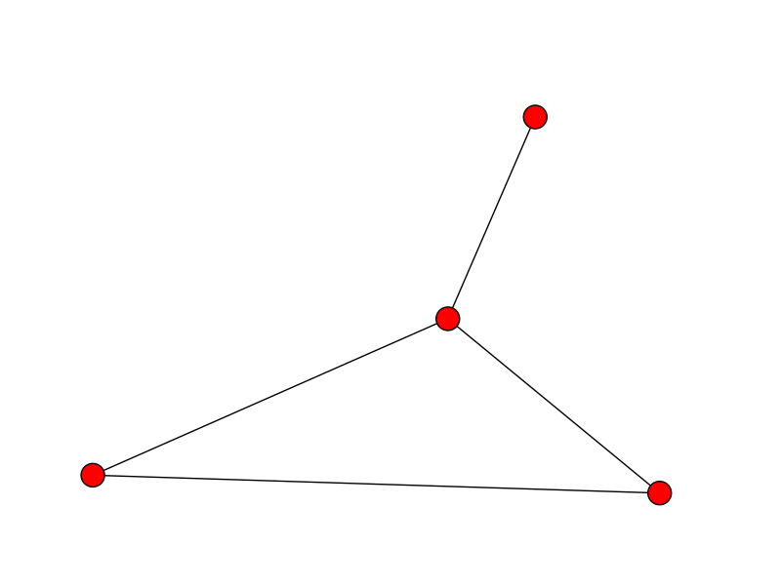
Step 3) Shortest paths
The shortest path between nodes a and d is: ______________________________
You can confirm this by typing:
print (nx.shortest_path(graph_name,node1,node2))
To make this work, you’ll need to replace graph_name, node1, and node2 by the appropriate content.
The command would be: nx.shortest_path(__________________________)

Step 4) Working with graphs
To add a free-floating node, you would type:
g.add_node(1) # this adds a node with the name “1”
To add a list of nodes, you would do:
g.add_nodes_from([2,3])
To remove a node (in this case, node 2), you would do:
g.remove_node(2)
To add an edge between node “a” and node “1” you would type:
g.add_edge(‘a’,1)
Run the commands above and sketch what your graph should look like. Do that without plotting the graph. Sketch here:

Step 5) Counting nodes & edges
To figure out how many nodes or how many edges you would do:
g.number_of_nodes() # or g.order()
g.number_of_edges() # or g.size()
Given this, what command would you type to figure out the mean edges per node (you should get .83333 if you did it right)? ____________________________________
*Hint: you can convert integer values (which is what things like g.order() return) into floats by type: float(g.order()), otherwise if you divide two integers it will “crop” your result into an integer and you’ll get the wrong answer.
To access the degree of a specific node, you could type: g.degree(node)
To see a list of all the nodes and edges, try: g.nodes() or g.edges(). So to iterate over all nodes and print their names, you could do:
for node in g.nodes():
print node
Modify this program to output the node’s name AND its degree:

Now draw a histogram of the degree distribution. Do this manually without writing code:

Here’s a program to draw the degree distribution:
degree = g.degree()
# a list of all the degree values:
degreevals = [val for (node, val) in degree]
degvaluniq = sorted(set(degreevals))

# this gets all the unique degree values, and sorts them
# so degvaluniq = [0, 1, 2, 3]
Now we want to know how many nodes are of each degree (how many have degree 0, 1, 2, 3, 4, etc.)
hist = [degreevals.count(x) for x in degvaluniq]
# which finds the number of nodes that have each degree count
Now, lets draw it:
plt.figure()
plt.plot(degvaluniq,hist,’ro-‘)
plt.xlabel(“Degree”)
plt.ylabel(“Number of nodes”)
plt.show()
And here is another option to draw the degree distribution:
degree = g.degree()
degreevals = [val for (node, val) in degree]

plt.hist(degreevals,bins=range(0,5), rwidth=1,align='left') #use matplotlib histogram function

plt.xlabel("Degree")

plt.ylabel("Number of nodes")

Step 6)
Let’s see if the graph is connected. Before you type this, what should the answer be?
nx.is_connected(g)
The connected components of this graph are:
____________________________________________
To have the networkx figure this out for you, you can do:
nx.connected_components(g)

You can convert this to a readable list of components by typing:
[comp for comp in nx.connected_components(g)]

Take a look at the two character interaction networks (downloaded from moviegalaxies.com). The one on the left is for the movie Babel. The one on the right is for pulp fiction
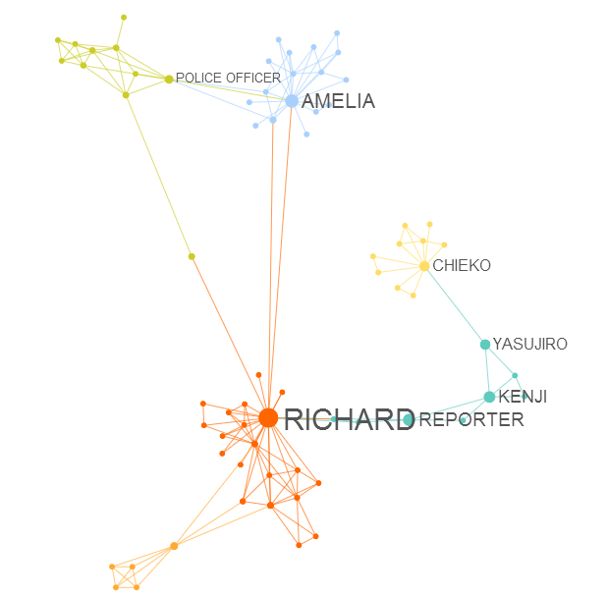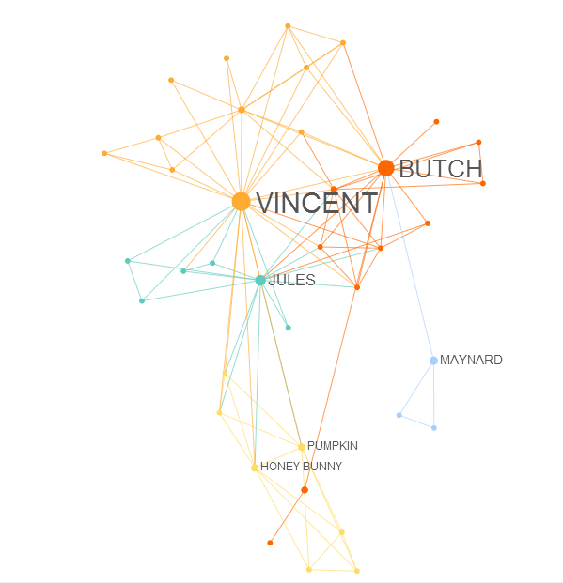
What are some obvious differences between the two:

I’ve uploaded the two network files onto the si608 canvas site. You can load them into memory using the command:
babel = nx.read_pajek(“babel.net”)
pulpfiction = nx.read_pajek(“pulp_fiction.net”)
To calculate diameter of a graph, you could do:
nx.diameter(babel)
For the density, try:
nx.density(babel)
To find the cliques in the graph you could do:
list(nx.find_cliques(babel))
# you need the list to “unpack” the object
What are the biggest cliques in each of the graphs? How can you easily identify this without going through the list?
Try this (and any other analysis you might want to do) for the two graphs.

